- . Create a vector of size 10 with values ranging from 0 to 1, both excluded.
import numpy as np

'''
Description of program:
This program creates a NumPy array of size 10 containing evenly spaced values
that range from 0 to 1, but explicitly excludes the values 0 and 1 themselves.
It demonstrates how to create arrays with specific value constraints and array slicing.
'''

def create_range_vector():
"""
Creates a vector of size 10 with values ranging from 0 to 1, both excluded

Returns:
A numpy array of size 10 with values between 0 and 1 (exclusive)
"""
# Create a vector with 10 equally spaced values between 0 and 1
vector = np.linspace(0, 1, 12)[1:-1]

return vector

# Test the function
result = create_range_vector()
print(result)

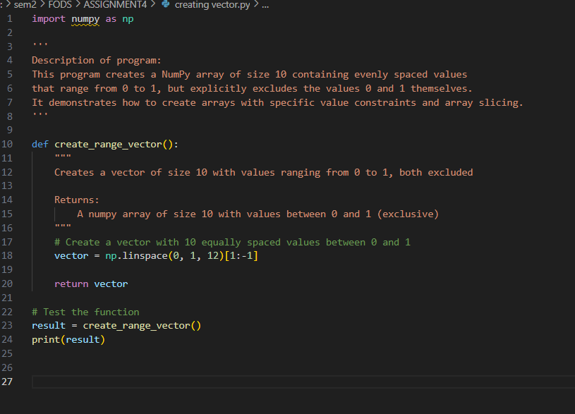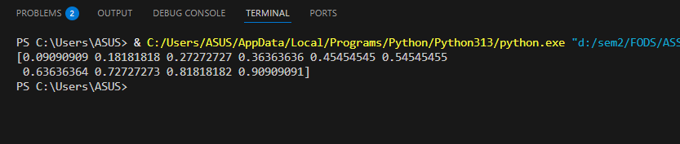

2)
import pandas as pd
import numpy as np
from datetime import datetime

'''
Description of program:
This program creates a Pandas DataFrame containing employee information and performs
multiple data analysis and manipulation operations on it. The operations include:
- Selecting specific columns (Name, Salary)
- Filtering rows based on conditions (department, age)
- Calculating aggregate statistics (average salary by department)
- Counting employees by department
- Adding calculated columns (Bonus)
- Replacing values (HR to Human Resources)
- Finding employees with longest tenure
- Creating categorical columns (SalaryCategory)
- Checking for and removing duplicates
- Calculating statistical measures (median age)

The program demonstrates a wide range of Pandas DataFrame operations that are
commonly used in data analysis and data manipulation tasks.
'''

def employee_operations():
"""
Performs various operations on an employee DataFrame to demonstrate Pandas functionality

Returns:
Results of various DataFrame operations
"""
# Create the employee DataFrame
data = {
'EmployeeID': [101, 102, 103, 104, 105],
'Name': ['John Smith', 'Alice Brown', 'Bob White', 'Emma Green', 'Charlie Red'],
'Department': ['IT', 'HR', 'IT', 'Finance', 'HR'],
'Age': [30, 28, 35, 40, 25],
'Salary': [70000, 60000, 80000, 90000, 55000],
'JoinDate': ['2018-07-15', '2020-03-10', '2016-11-01', '2012-05-25', '2021-06-01'],
'ExperienceYears': [5, 3, 7, 11, 2]
}

# Create DataFrame
df = pd.DataFrame(data)

# Convert JoinDate to datetime
df['JoinDate'] = pd.to_datetime(df['JoinDate'])

print("Original DataFrame:")
print(df)
print("\n")

# a. Select only Name and Salary columns
name_salary = df[['Name', 'Salary']]
print("a. Name and Salary columns:")
print(name_salary)
print("\n")

# b. Filter out all employees in the "IT" department
non_it_employees = df[df['Department'] != 'IT']
print("b. Employees not in IT department:")
print(non_it_employees)
print("\n")

# c. Select employees who are older than 30
older_employees = df[df['Age'] > 30]
print("c. Employees older than 30:")
print(older_employees)
print("\n")

# d. Average salary by department
avg_salary_by_dept = df.groupby('Department')['Salary'].mean()
print("d. Average salary by department:")
print(avg_salary_by_dept)
print("\n")

# e. Count employees in each department
employees_by_dept = df.groupby('Department').size()
print("e. Number of employees in each department:")
print(employees_by_dept)
print("\n")

# f. Add Bonus column (10% of salary)
df['Bonus'] = df['Salary'] * 0.1
print("f. DataFrame with Bonus column:")
print(df)
print("\n")

# g. Replace "HR" with "Human Resources"
df['Department'] = df['Department'].replace('HR', 'Human Resources')
print("g. DataFrame with 'HR' replaced:")
print(df)
print("\n")

# h. Find employee(s) with longest tenure
longest_tenure = df[df['JoinDate'] == df['JoinDate'].min()]
print("h. Employee(s) with longest tenure:")
print(longest_tenure)
print("\n")

# i. Create SalaryCategory column
df['SalaryCategory'] = np.where(df['Salary'] > 75000, 'High', 'Low')
print("i. DataFrame with SalaryCategory column:")
print(df)
print("\n")

# j. Check for duplicate EmployeeIDs and remove if found
print("j. Checking for duplicate EmployeeIDs:")
duplicates = df[df.duplicated('EmployeeID')]
if len(duplicates) > 0:
print(f"Found {len(duplicates)} duplicates")
df = df.drop_duplicates('EmployeeID')
print("After removing duplicates:")
print(df)
else:
print("No duplicate EmployeeIDs found")
print("\n")

# k. Calculate median Age
median_age = df['Age'].median()
print(f"k. Median Age of all employees: {median_age}")

return df

# Test the function
result_df = employee_operations()

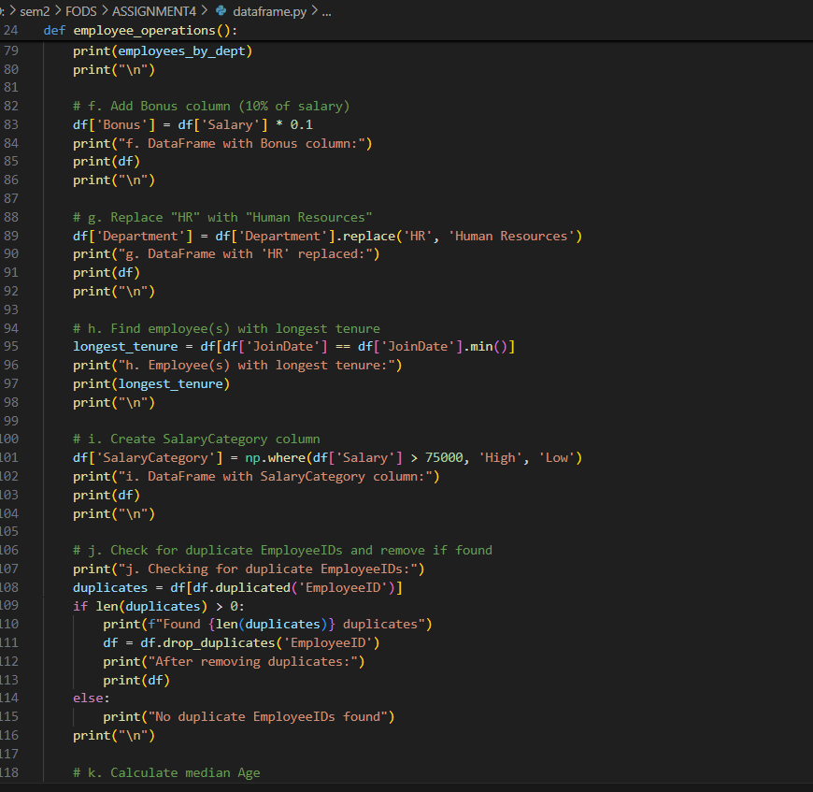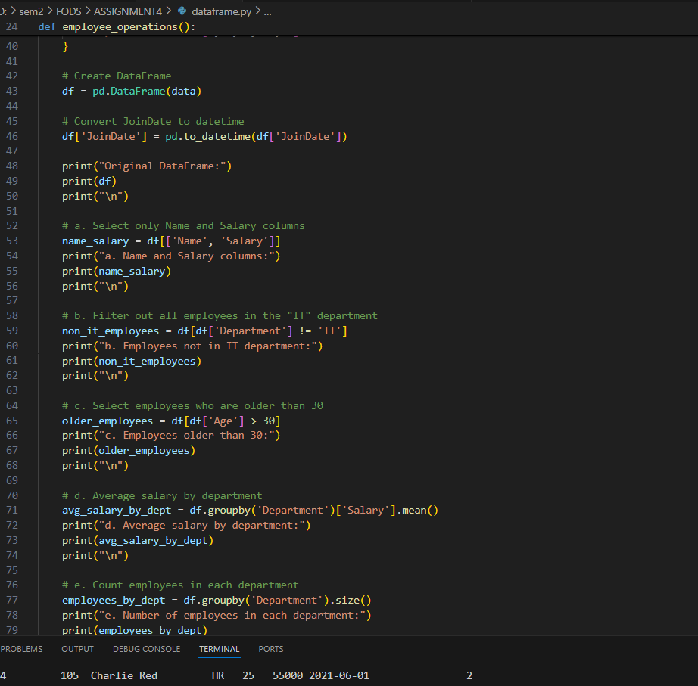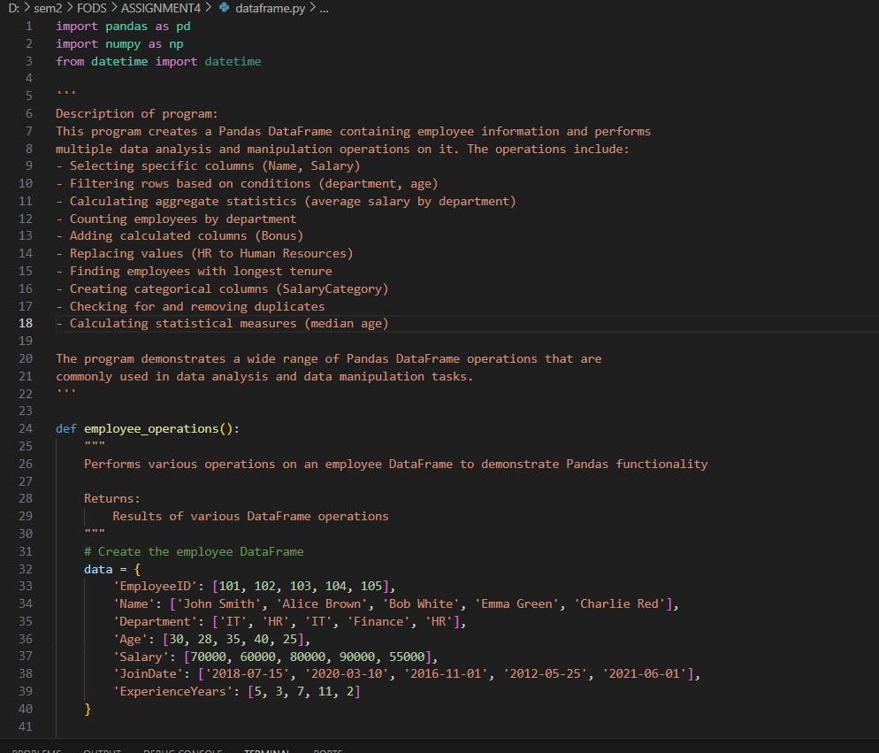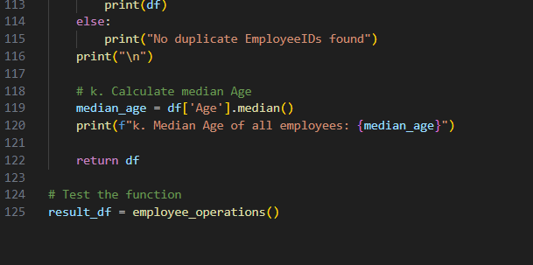
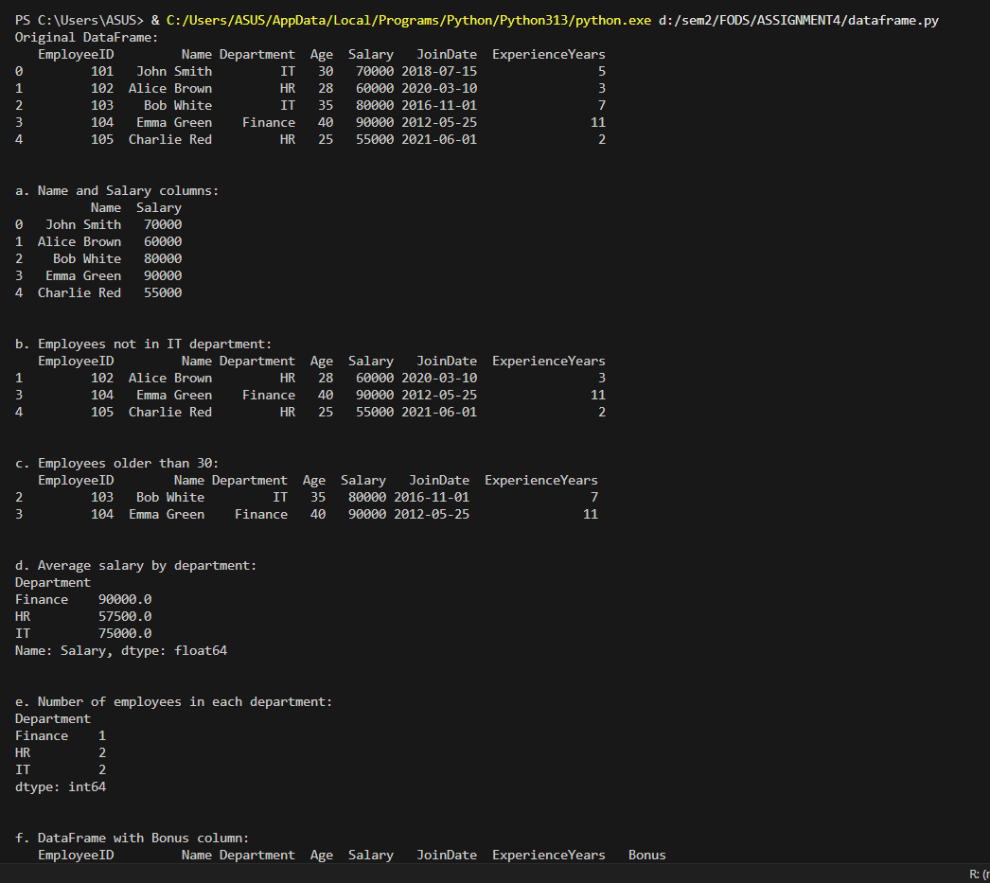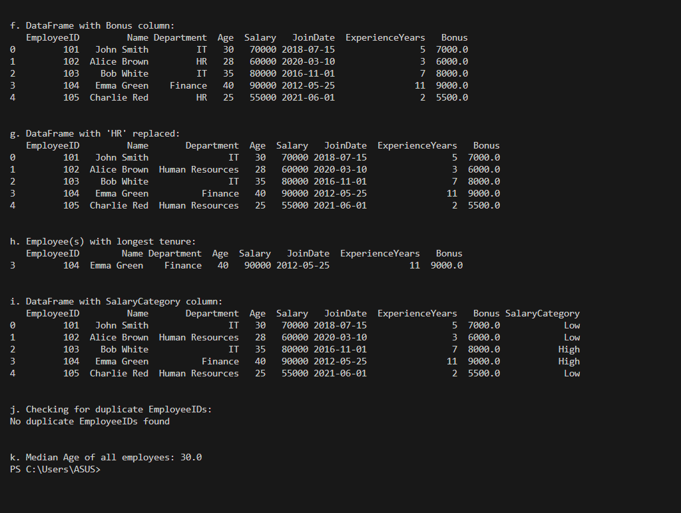

3)
import numpy as np

'''
Description of program:
This program creates a 3x4 matrix that resembles an identity matrix.
While a true identity matrix must be square, this program creates a rectangular
matrix with 1s on the main diagonal (where row index equals column index)
and 0s elsewhere. This demonstrates matrix creation and manipulation in NumPy.
'''

def create_identity_matrix():
"""
Creates an identity matrix of shape (3,4)

Returns:
A numpy array representing a 3x4 identity-like matrix
"""
# Note: A true identity matrix must be square, but we can create a 3x4 matrix
# that has 1s on the main diagonal and 0s elsewhere

# Create a 3x4 matrix of zeros
matrix = np.zeros((3, 4))

# Set 1s on the main diagonal where possible
for i in range(min(3, 4)):
matrix[i, i] = 1

return matrix

# Test the function
result = create_identity_matrix()
print(result)
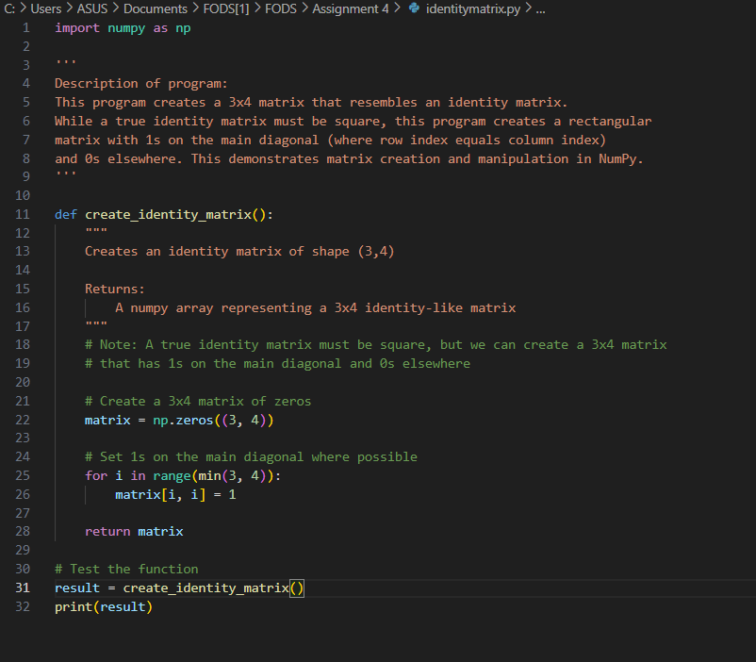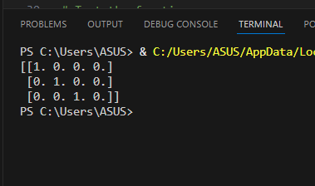
4)
import numpy as np

'''
Description of program:
This program takes user input to create an array of at least 10 numbers.
It then sorts the array and performs various slicing operations to extract
elements from specific index ranges (2-5, 5-8, and 2-9).
The program demonstrates array input, sorting, and slicing operations in NumPy.
'''

def array_operations():
"""
Takes user input for an array, sorts it, and performs slicing operations

Returns:
The original array, sorted array, and various slices
"""
# Get user input for array elements
input_str = input("Enter at least 10 numbers separated by spaces: ")

# Convert input string to a list of numbers
input_list = [float(x) for x in input_str.split()]

# Check if at least 10 elements were provided
if len(input_list) < 10:
print("Error: Please enter at least 10 numbers")
return None

# Convert to numpy array and sort
array = np.array(input_list)
sorted_array = np.sort(array)

# Perform slicing operations
slice_2_5 = sorted_array[2:6] # Elements from index 2 to 5 (inclusive)
slice_5_8 = sorted_array[5:9] # Elements from index 5 to 8 (inclusive)
slice_2_9 = sorted_array[2:10] # Elements from index 2 to 9 (inclusive)

return array, sorted_array, slice_2_5, slice_5_8, slice_2_9

# Test the function
result = array_operations()
if result:
original, sorted_arr, slice1, slice2, slice3 = result
print("Original array:", original)
print("Sorted array:", sorted_arr)
print("Elements between indexes 2-5:", slice1)
print("Elements between indexes 5-8:", slice2)
print("Elements between indexes 2-9:", slice3)

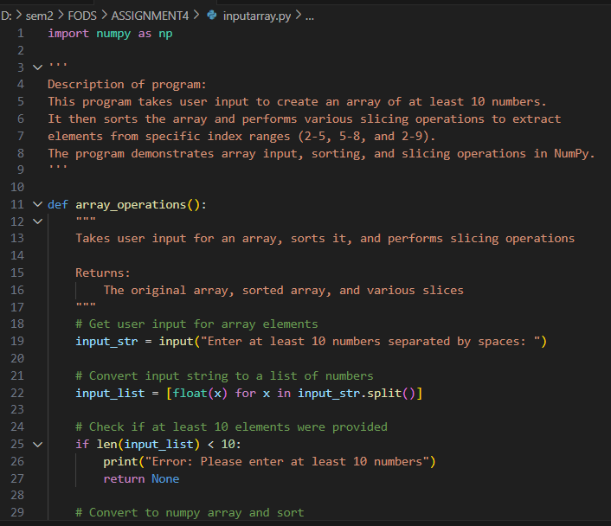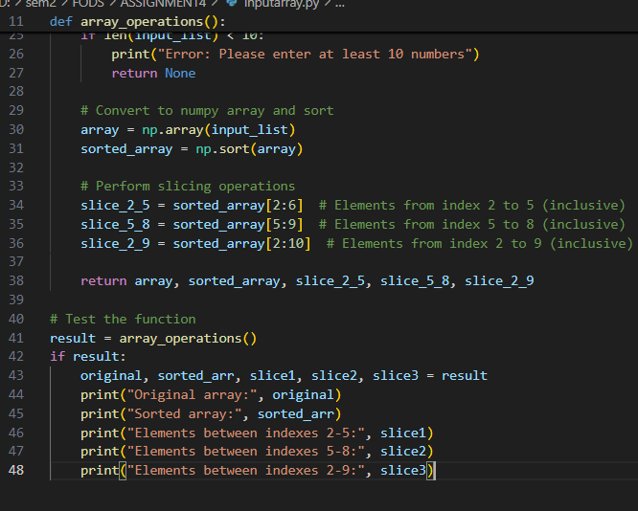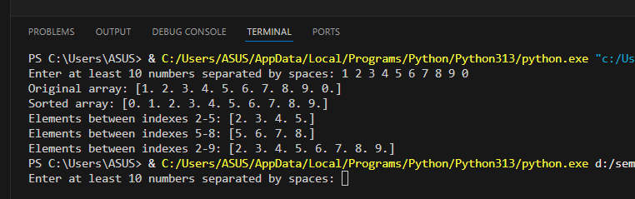
5)
import numpy as np

'''
Description of program:
This program creates a 5x5 matrix where each row contains the values [0, 1, 2, 3, 4].
The program demonstrates how to create and manipulate arrays to form specific matrix patterns.
It uses NumPy's arange and tile functions to efficiently generate the structured matrix.
'''

def create_row_matrix():
"""
Creates a 5x5 matrix with row values ranging from 0 to 4

Returns:
A 5x5 numpy array where each row contains values from 0 to 4
"""
# Create a row vector [0, 1, 2, 3, 4]
row = np.arange(5)

# Repeat the row 5 times to create a 5x5 matrix
matrix = np.tile(row, (5, 1))

return matrix

# Test the function
result = create_row_matrix()
print(result)
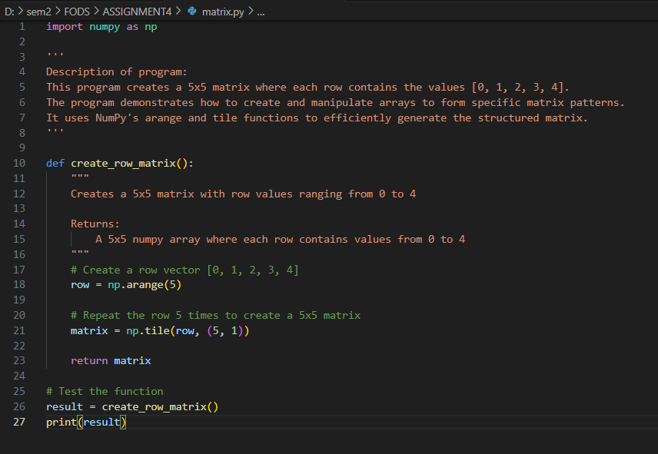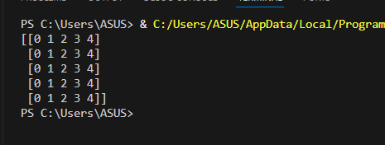
6)
import numpy as np

'''
Description of program:
This program creates a NumPy array (vector) of size 10 filled with zeros.
Then it sets the fifth element (index 4) to 1.
The program demonstrates basic NumPy array creation and element manipulation.
'''

def create_special_vector():
"""
Creates a zero vector of size 10 with the fifth value (index 4) set to 1

Returns:
A numpy array of size 10 with zeros and a 1 at index 4
"""
# Create a vector of zeros
vector = np.zeros(10)

# Set the fifth value (index 4) to 1
vector[4] = 1

return vector

# Test the function
result = create_special_vector()
print(result)
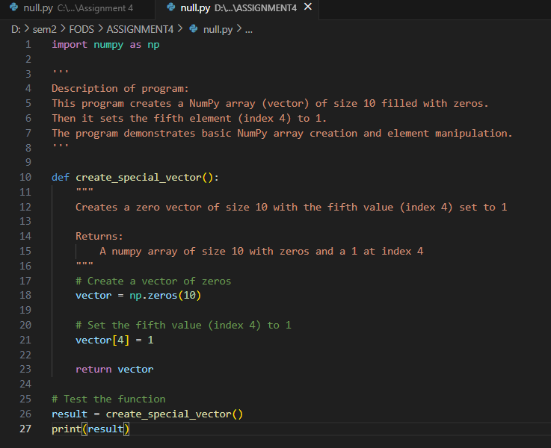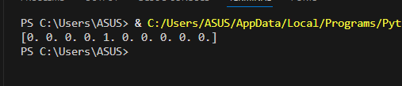
7)
import pandas as pd

'''
Description of program:
This program creates two Pandas Series objects with the same index values.
It then performs four basic arithmetic operations on these Series:
addition, subtraction, multiplication, and division.
The program demonstrates Pandas Series creation and element-wise operations
between Series objects. It shows how Pandas aligns data by index values
when performing operations.
'''

def pandas_series_operations():
"""
Performs addition, subtraction, multiplication, and division on two Pandas Series

Returns:
The two Series and the results of operations
"""
# Create two pandas Series
series1 = pd.Series([10, 20, 30, 40, 50], index=['a', 'b', 'c', 'd', 'e'])
series2 = pd.Series([5, 10, 15, 20, 25], index=['a', 'b', 'c', 'd', 'e'])

# Perform operations
addition = series1 + series2
subtraction = series1 - series2
multiplication = series1 * series2
division = series1 / series2

return series1, series2, addition, subtraction, multiplication, division

# Test the function
s1, s2, add, sub, mul, div = pandas_series_operations()
print("Series 1:")
print(s1)
print("\nSeries 2:")
print(s2)
print("\nAddition:")
print(add)
print("\nSubtraction:")
print(sub)
print("\nMultiplication:")
print(mul)
print("\nDivision:")
print(div)
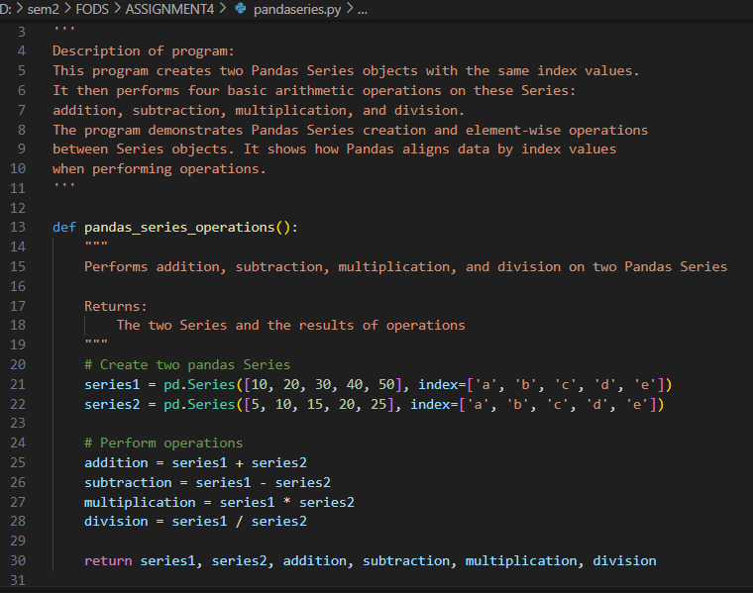
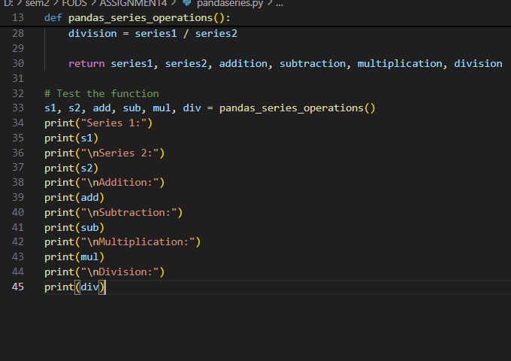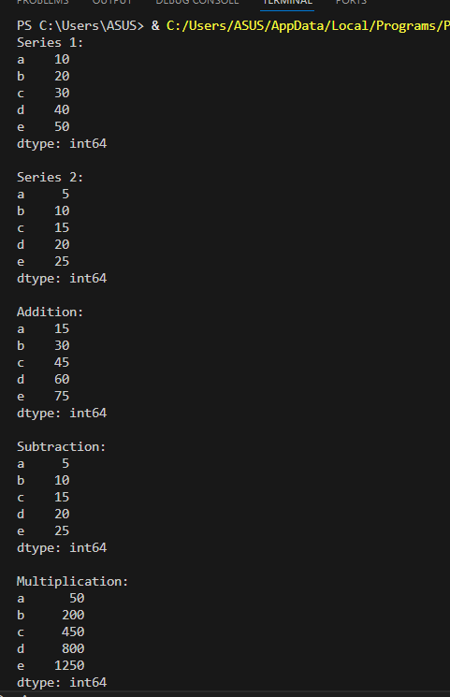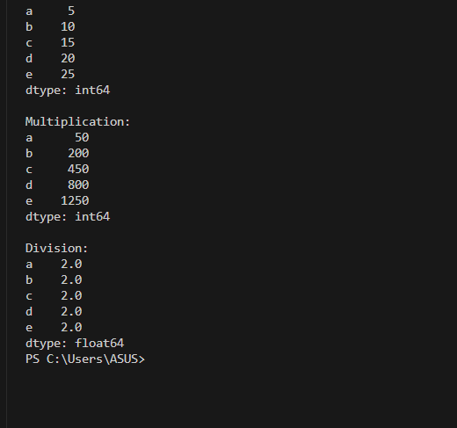
8)
import numpy as np

'''
Description of program:
This program takes two inputs from the user: number of rows (a) and number of columns (b).
It then creates a random NumPy array of shape (a, b) with values between 0 and 1.
The program calculates and displays the average value of all elements in the array.
This demonstrates user input, random array generation, and basic array statistics in NumPy.
'''

def generate_random_array():
"""
Generates a random array with shape specified by the user and calculates its average

Returns:
A random numpy array and its average value
"""
# Get user input for array dimensions
a = int(input("Enter number of rows: "))
b = int(input("Enter number of columns: "))

# Generate random array of shape (a, b)
random_array = np.random.rand(a, b)

# Calculate average of the array
array_avg = np.mean(random_array)

return random_array, array_avg

# Test the function
array, avg = generate_random_array()
print("Generated array:")
print(array)
print("\nAverage of the array:", avg)
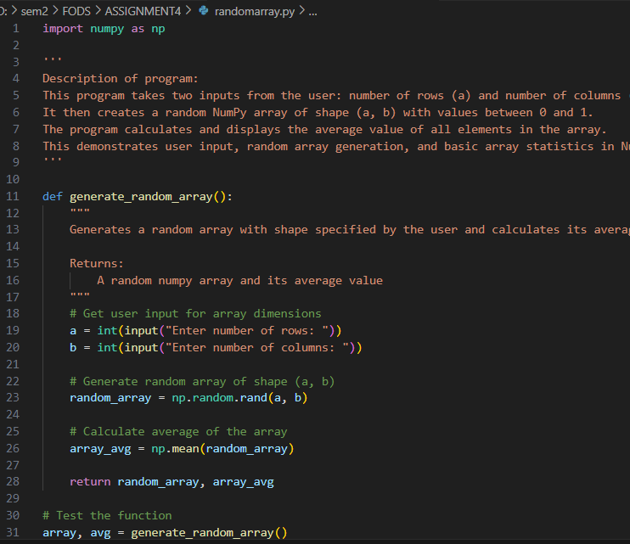
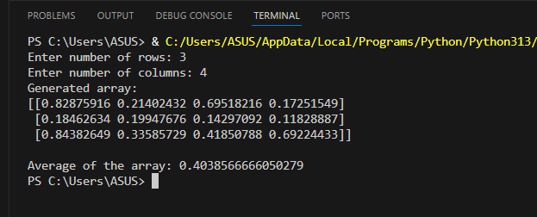
9)
import numpy as np

'''
Description of program:
This program creates a random array of 10 integers, sorts it, and then
reshapes it into two different matrix dimensions: 2x5 and 5x2.
The program demonstrates random array generation, sorting, and reshaping operations in NumPy.
It shows how the same data can be restructured into matrices with different dimensions
while preserving the data values and their order.
'''

def reshape_array():
"""
Creates an array of random integers, sorts it, and reshapes it into different dimensions

Returns:
The original array, sorted array, and reshaped arrays
"""
# Create a random array of integers (1x10)
random_array = np.random.randint(1, 100, 10)

# Sort the array
sorted_array = np.sort(random_array)

# Reshape into 2x5 matrix
reshaped_2x5 = sorted_array.reshape(2, 5)

# Reshape into 5x2 matrix
reshaped_5x2 = sorted_array.reshape(5, 2)

return random_array, sorted_array, reshaped_2x5, reshaped_5x2

# Test the function
original, sorted_arr, reshape1, reshape2 = reshape_array()
print("Original array:", original)
print("Sorted array:", sorted_arr)
print("\nReshaped into 2x5 matrix:")
print(reshape1)
print("\nReshaped into 5x2 matrix:")
print(reshape2)
